End of EYFS |  | Talk about the lives of the people around them and their roles in society.  Know some similarities and differences between things in the past and now, drawing on their experiences and what has been read in class.  Understand the past through settings, characters and events encountered in books read in class and storytelling.  Describe their immediate environment using knowledge from observation, discussion, stories, non-fiction texts and maps.  Know some similarities and differences between different religious and cultural communities in this country, drawing on their experiences and what has been read in class.  Explain some similarities and differences between life in this country and life in other countries, drawing on knowledge from stories, non-fiction texts and – where appropriate - maps.  Explore the natural world around them, making observations and drawing pictures of animals and plants.  Know some similarities and differences between the natural world around them and contrasting environments, drawing on their experiences and what has been read in class.  Understand some important processes and changes in the natural world around them, including the seasons and changing states of matter.
Caterpillars
 | All about me |  | Colours Everywhere | On the go | On the farm | Yummy foods | Seaside
 | 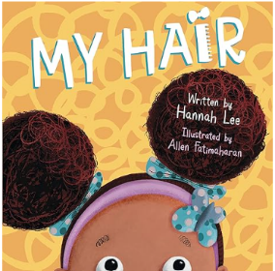 |  | 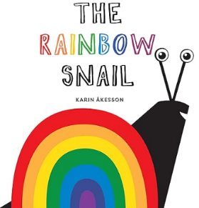 | 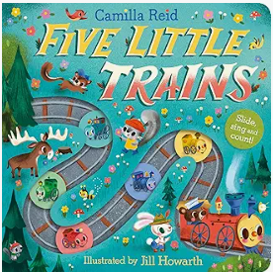 | 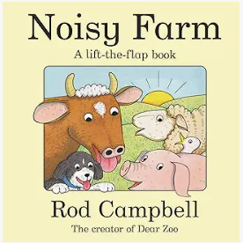 | 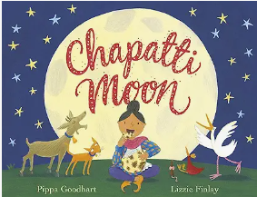 | 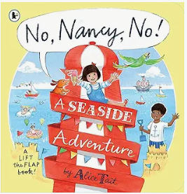
 | Explore and respond to different natural phenomena in their setting and on trips.  Explore materials with different properties.  To name some types of rooms in house e.g. Living Room, Kitchen, Bedroom, Bathroom, Garden  To know that they are at nursery within a school near their house. |  | Explore and respond to different natural phenomena in their setting and on trips. Explore natural materials, indoors and outside.  To explore the features of their classroom environment and the outdoor environment | Explore and respond to different natural phenomena in their setting and on trips. Explore materials with different properties.  To begin to use positional language involving objects | Explore and respond to different natural phenomena in their setting and on trips. Explore natural materials, indoors and outside. | Explore and respond to different natural phenomena in their setting and on trips. | Explore and respond to different natural phenomena in their setting and on trips. Explore natural materials, indoors and outside.
 | I can talk about the weather.  I can observe how living things grow.  garden.  Talk about the weather. |  | I can explore colour.  I can investigate and respond to autumnal objects.  Exploring squelching in mud with wellies. Talk about the weather. | I can look for signs of Winter.  I can explore different vehicles and how they move. | I can look for signs of Spring. | I can observe how living things grow. | I can look for signs of Summer.
Butterflies
 | All about me |  | Celebrations of the world | Pirates! | New Life | Traditional tales | People who help us
 | 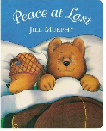 |  | 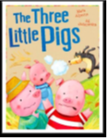 | 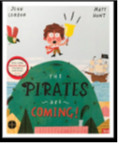 | 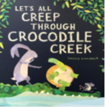 | 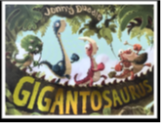 | 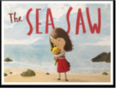
 | To name different types of rooms in house e.g. Living Room, Kitchen, Bedroom, Bathroom, Garden. –  To name places in the local community e.g. park, shop, house, road, doctors, library |  | Use all their senses in hands-on exploration of natural materials. Explore collections of materials with similar and/or different properties.  Talk about the differences between materials and changes they notice. | Talk about what they see, using a wide vocabulary.  Explore and talk about different forces they can feel.  Use all their senses in hands-on exploration of natural materials. Explore collections of materials with similar and/or different properties. | Plant seeds and care for growing plants. Understand the key features of the life cycle of a plant and an animal. Begin to understand the need to respect and care for the natural environment and all living things. | Understand the key features of the life cycle of plant and an animal. and/or different properties.  Talk about what they see, using a wide vocabulary
 | I can talk about how I have grown from when I was a baby.  I can talk about how I look different from when I was a baby and now, what I can do now. e.g. size of clothes etc. |  | .I can talk about how I know it is the autumn time by looking at the environment around me. | I can talk about how I know it is the winter time by looking at the environment around me.  I can use words to describe the cold and what happens when ice is in my hand. I can explore forces. | I can talk about how I know it is the spring time by looking at the environment around me. I can explain that plants grow and die over time.  I know that you have to look after and take care of living things to help them to grow. I can talk about how animals grow | I can talk about the materials of some objects and say if they are hard and soft, strong or weak.  I can explain which materials would make a strong bridge. | I can talk about how I know it is the summer time by looking at the environment around me.  I can talk about which materials float and sink. I can begin to explain why some materials float and sink.
Reception
 | All about me! |  | Mini-beasts | Transport | The World | Animals | Superheroes
 | 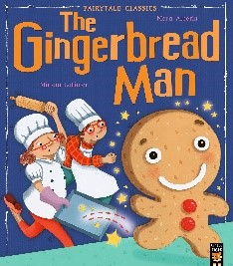 |  | 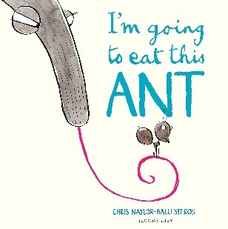 | 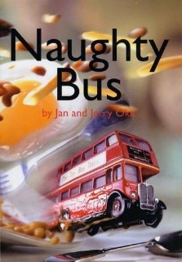 | 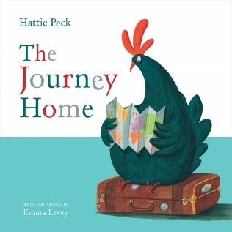 | 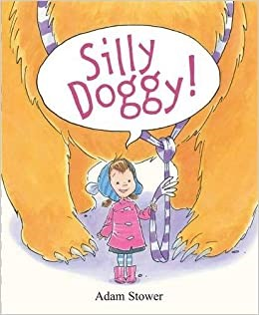 | 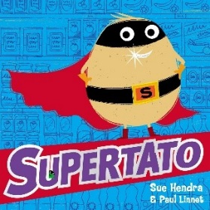
 | Understand the effect of changing seasons on the natural world around them.  Describe what they see, hear and feel whilst outside. |  | Understand the effect of changing seasons on the natural world around them.  Explore the natural world around them. | Understand the effect of changing seasons on the natural world around them.  Explore and talk about different forces they can feel. | Understand the effect of changing seasons on the natural world around them.  Describe what they see, hear and feel whilst outside. | Explore the natural world around them. | Understand the effect of changing seasons on the natural world around them.
 | I can understand my 5 senses and use them to learn about my environment.  I can talk about autumn and describe how some things in my environment are changing e.g. leaves, weather. |  | I can talk about autumn and describe how some things in my environment are changing e.g. leaves, weather. I can discover the animals in my environment.  I can explain what happens when you freeze water. I can talk about how to turn ice back into water by melting.  I will investigate how to melt ice in different ways. | I can talk about winter and describe how some things in my environment are changing.  I can explore forces using vehicles and ramps | I can talk about spring and describe how some things in my environment are changing.  I can investigate plants and recognise and explain that plants grow. | I can explore how a magnet attracts an object.  I can explore how a boat floats on water. | I can talk about summer and describe how some things in my environment are changing.  I can explain why some foods are healthy or unhealthy. I can explain why it is important to exercise.

