.End of EYFS | Be confident to try new activities and show independence, resilience and perseverance in the face of challenge.  Show an understanding of their own feelings and those of others, and begin to regulate their behaviour accordingly.  Explain the reasons for rules; know right from wrong and try to behave accordingly.  Work and play cooperatively and take turns with others.  Form positive attachments to adults and friendships with peers.  Show sensitivity to their own and to others’ needs
Caterpillars
 | All about me | Colours Everywhere | On the go | On the farm | Yummy foods | Seaside
 | 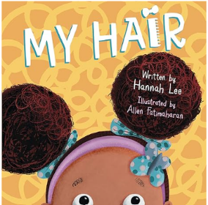 | 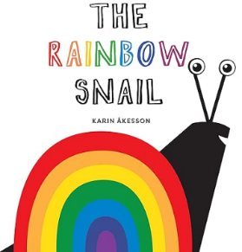 | 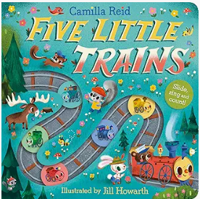 | 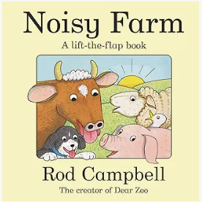 | 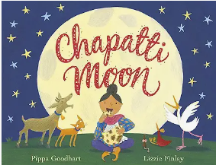 | 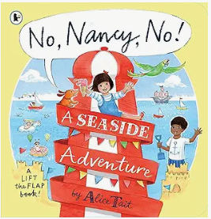
 | Can I mostly manage separating from my main carer and explore my environment with support and encouragement from a familiar adult?  What is my name?  What am I good at?  What is my friend good at? | Have I built relationships with people who are special to me but still show anxiety in the presence of strangers?  Am I a girl or boy?  Where do I like to play? | Am I seeking out others to share experiences with and choosing to play with a familiar child who likes the same things as me?  Do I share my ideas, wants and interests? | Can I show empathy towards others who are special to me?  Which toy does my friend like?  Do I experiment with playing different roles during my imaginative play?  Can I seek comfort from a familiar person when needed? | Am I becoming more confident and cooperative in situations with familiar people and environments?  How am I kind towards others?  What is an unkind thing to do? | Do I show an awareness of others perspectives, ideas and needs that are different to mine?  Am I starting to follow familiar everyday rules and routines?  Can I show a range of emotions?  Am I sometimes able to distract myself if I get upset?  How do I feel today?
Butterflies
 | All about me | Celebrations of the world | Pirates! | New Life | Traditional tales | People who help us
 |  |  |  | 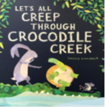 |  | 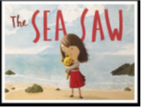
 | Can I seek out adults and other children to share my experiences and ideas with?  How am I the same as my friends?  How am I different to my friends? | Do I copy what I have seen adults do to help me with my own friendships and interactions?  What things do I help my teacher with at school?  What jobs do I help with at home?  Do I listen to and follow instructions? | Am I more able to show consideration for others needs?  Can I take turns and share without adult support?  How I respond to praise and encouragement?  What am I scared of? | Can I negotiate, show assertiveness and compromise or seek out an adult to help when resolving conflicts with peers?  Who do I ask if I need help?  Can I make the right choices most of the time?  Can I take care of Nursery resources? | What is my friend’s name?  What do they like to play with?  What do my friends like about me?  Can I show awareness and talk about how others might be feeling?  What can I do to help if my friend is sad? | Do I enjoy playing alone, alongside and with others, sometimes inviting them to play and attempting to join in their play?  How do I show my developing confidence and self-esteem?  Am I expressing a wide range of feelings through behaviour and play?
Reception
 | All about me! | Mini-beasts | Transport | The World | Animals | Superheroes
 | 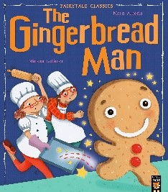 |  |  | 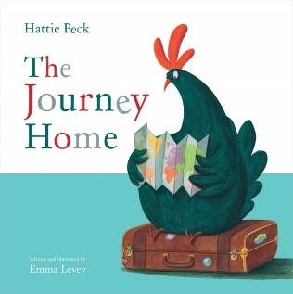 |  | 
 | Who are my friends’?  What is a friend?  What does my friend think, do we always agree or do we have different ideas sometimes?  What do I do at home?  Do I show an understanding of choices and consequences?  How can I sort out this problem? | Do I act out what I have seen adults do during my play?  What do I like to play?  What do I need?  What do I think?  What is fair and unfair?  What are the school rules?  Can I talk about a different range of festivals? | Who do I go to if I need some support in a difficult situation?  What am I good at?  What am I working on improving?  What would I do if my feelings or wishes cannot be met?  Can I talk about why I made a particular choice? | What makes a good friend?  Why is it important to include everyone in my play?  Do I always choose the same friends to play with?  How does my friend feel today?  Do I show empathy towards others? | Can I show an awareness of others needs and play co-operatively?  What things do I need to carry out this activity?  Will I persevere even if it becomes tricky?  Can I talk about my own and others feelings? | Can I resolve conflict with and without support?  During my play, can I confidently express my ideas and what I want to do?  If I hurt someone else or I’m unkind to a friend, do I know of ways I can try to make it better?
Special Events |  | Bonfire Night  Diwali  Christmas | Lunar New Year  Pancake Day | Easter

