.End of EYFS | Listen attentively and respond to what they hear with relevant questions, comments and actions when being read to and during whole class discussions and small group interactions.  Make comments about what they have heard and ask questions to clarify their understanding.  Hold conversation when engaged in back-and-forth exchanges with their teacher and peers.  Give focused attention to what the teacher says, responding appropriately even when engaged in activity, and show an ability to follow instructions involving several ideas or actions.  Demonstrate understanding of what has been read to them by retelling stories and narratives using their own words and recently introduced vocabulary.  Anticipate – where appropriate – key events in stories.  Use and understand recently introduced vocabulary during discussions about stories, non-fiction, rhymes and poems during role-play.  Participate in small group, class and one-to-one discussions, offering their own ideas, using recently introduced vocabulary.  Offer explanations for why things might happen, making use of recently introduced vocabulary from stories, non-fiction, rhymes and poems when appropriate.  Express their ideas and feelings about their experiences using full sentences, including use of past, present and future tenses and making use of conjunctions, with modelling and support from their teacher.
Caterpillars
 | All about me | Colours Everywhere | On the go | On the farm | Yummy foods | Seaside
 | 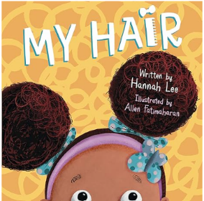 | 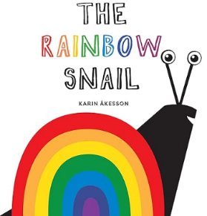 | 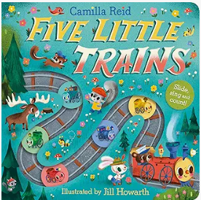 | 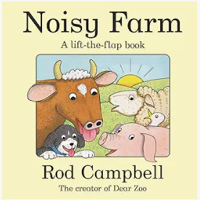 | 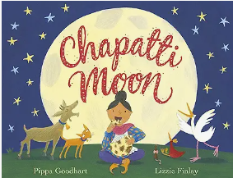 | 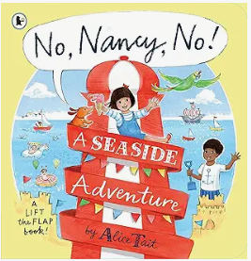
 | Do I show an interest in play with sounds, songs and rhymes?  What noise does an owl make?  Are the owls awake in the day or night?  Can I use language to share my feelings, thoughts and experiences? | Can I recognise and respond to a range of familiar sounds?  What is making that noise?  Where is that noise coming from?  What does the bear see?  Am I learning and using new words quickly and using them to communicate? | Can I listen with interest to the noises adults make when reading stories?  What noise would it make if we walked through mud?  Can I identify an action word by following simple instructions such as; show me walking, jumping and sitting? | Do I respond to my name most of the time?  Am I starting to understand two part instructions?  Where are the baby and her Mummy?  Can I hold a simple conversation? | What sound does a train make?  Which animal makes a ‘baaa’ noise?  Is a train fast or slow?  Can I start to communicate using longer sentences?  Am I beginning to use word endings, e.g. cats, going? | What can you hear around you?  Is the monkey happy or sad?  Am I developing and understanding of who, what and where in simple questions?  Can I use a variety of simple questions?
Butterflies
 | All about me | Celebrations of the world | Pirates! | New Life | Traditional tales | People who help us
 | 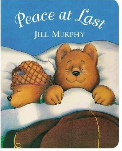 | 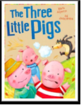 | 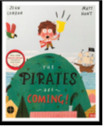 | 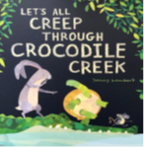 | 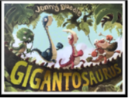 | 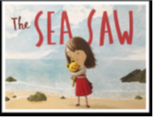
 | What might happen next?  Can I listen to and follow instructions when I am busy in my play?  Do I join in with singing new and familiar songs?  Can I communicate using more complex sentences to link my thoughts by using and or because? | Can I join in with repeated parts of a familiar story?  Which word comes next, I’ll huff and I’ll......?  Why couldn’t the wolf blow down the house of bricks?  Can I re-tell events that have happened in the past accurately?  Who are the characters in this book? | Can I listen to familiar books with increasing attention and recall?  What is happening in the story now?  Can I notice and correct my teacher if they make a mistake when singing a familiar rhyme?  Do I show an understanding of the use of objects; for example, what do we use to cut with? | What happens at the start of the story?  What does a pirate say?  Can I respond appropriately to more complex instructions?  Where does the boy stand when he is watching out for the pirates?  What things are important to me?  Can I show an understanding of how and why questions?  Do I question why things happen? | Can I listen to others one-to-one or in small groups when I am interested in the conversation?  What sounds does the dinosaur make throughout the book?  Am I showing an understanding of prepositions such as under, on top and behind?  Can I use talk to pretend during my play? | What might happen at the end of the story?  What might you hear at the seaside?  Where is the story set?  How did the sea help the bear?  Am I beginning to use a range of tenses?  Am I displaying a vocabulary that reflects the breadth of my experiences?
Reception
 | All about me! | Mini-beasts | Transport | The World | Animals | Superheroes
 | 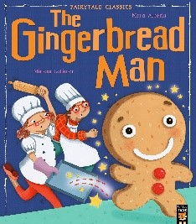 | 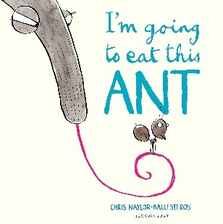 | 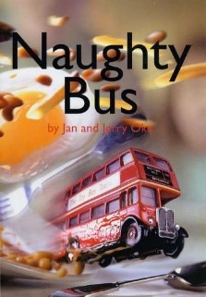 | 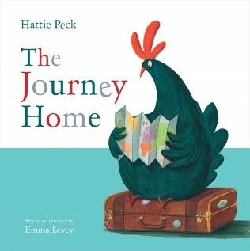 | 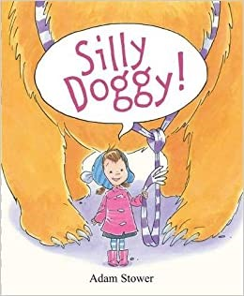 | 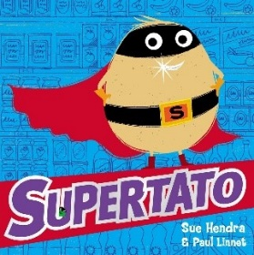
 | Can I listen for extended periods of time without being easily distracted most of the time?  Why does the gingerbread man run away from Mr and Mrs Baker?  Do I independently introduce a storyline line or narrative to my play? | What is a habitat?  Can I confidently follow a story without needing pictures of props?  Am I consistently using newly introduced vocabulary when talking?  How could the character solve that problem? | Can I understand and follow a range of more complex sentences and instructions?  Where does the bus go?  Can I take turns in conversation?  Can I begin to talk about why things happen using new vocabulary learnt? | Can I make predictions and give explanations as to what might happen or is happening in a story?  Can I confidently use language to imagine and recreate roles and experiences in play situations?  When did the hatchlings leave home? | Why is this story funny?  Where does the girl find the animals?  Can I understand questions such as who, why, when, where and how?  Can I listen and respond to the ideas of my friends during conversations?  What is a fiction book?  What is a non-fiction book? | Who is the main character?  What is a hero?  Who is the baddie?  How does the story end?  Can I use talk for a range of purposes; such as, to organise, sequence and clarify thinking, ideas, feelings and events?

