.End of EYFS | Negotiate space and obstacles safely, with consideration for themselves and others. Demonstrate strength, balance and coordination when playing. Move energetically, such as running, jumping, dancing, hopping, skipping and climbing. Hold a pencil effectively in preparation for fluent writing – using the tripod grip in almost all cases. Use a range of small tools, including scissors, paint brushes and cutlery. Begin to show accuracy and care when drawing. Manage their own basic hygiene and personal needs, including dressing, going to the toilet and understanding the importance of healthy food choices
Caterpillars
 | All about me | Colours Everywhere | On the go | On the farm | Yummy foods | Seaside
 | 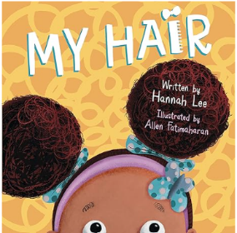 | 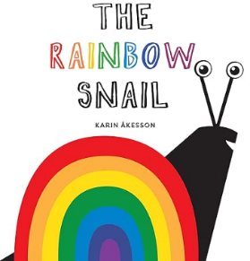 | 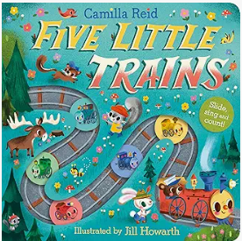 | 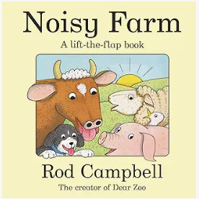 |  | 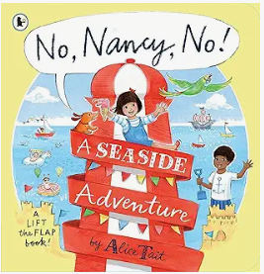
 | Can I look at a book independently turning the pages? Which hand do I hold my pencil in? Do I make different marks on paper with pens and pencils? How do I hold a pencil? | Can I move in response to music? Do I choose to use bikes, scooters and ride on toys with developing control? Do I attempt to put on my own coat? Am I showing an interest in what the toilet/potty are used for? Can I tell an adult when I need to use the toilet/potty? | Do I wash my hands after getting muddy outside with some support? Can I copy movements in response to a story? Can I use stairs going up and down with both feet on each step whilst holding on? | Do I join in with food tasting? Can I name any fruits? Can I sit comfortably on a chair with both feet on the ground? Can I feed myself competently? Do I hold a cup with two hands and drink well? | Do I join in with food tasting? Can I name any fruits? Can I sit comfortably on a chair with both feet on the ground? Can I feed myself competently? Do I hold a cup with two hands and drink well? | Am I starting to show control when using a range of tools and objects such as jugs, hammers and mark making tools? Can I choose different ways to move? Am I starting to recognise danger? Will I seek comfort and support from a familiar adult if I need it? Can I start to express my thoughts and emotions through words
Butterflies
 | All about me | Celebrations of the world | Pirates! | New Life | Traditional tales | People who help us
 | 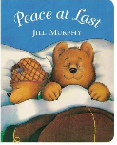 | 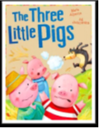 | 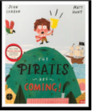 | 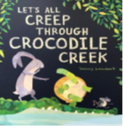 | 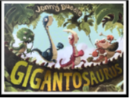 | 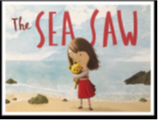
 | Can I climb stairs and move across climbing equipment whilst keeping my balance? Am I moving with more balance and stability when carrying objects? Can I throw and catch a ball or bean bag with two hands? Am I showing a preference for a dominant hand? | Will I happily try a range of foods? What is my favourite food? Can I independently put on my own coat and do up the zip with some support? Can I take care of my toileting needs independently? | Can I describe my daily routine and am I able to talk about why it is important? When I draw, can I create lines and circles? | Can I run around without bumping in to things or other children? Can I balance on one foot? What changes can I notice happen to my body when I have been physical? | Can I name different parts of my body? Do I use a range of tools with one hand? How do I use tools safely? Can I use a tripod grip to hold my pencil? Can I form some letters from my name? | Can I tell and adult if I am hungry, full up, tired, want to rest or play? When needed, can i observe and control my breath by taking deep breaths and scrunching/releasing it?
Reception
 | All about me! | Mini-beasts | Transport | The World | Animals | Superheroes
 | 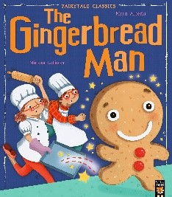 | 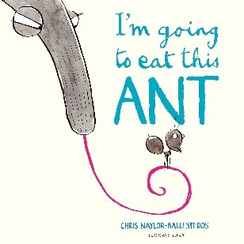 | 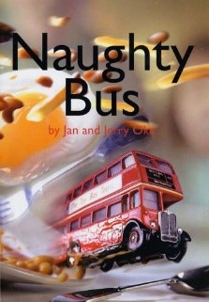 | 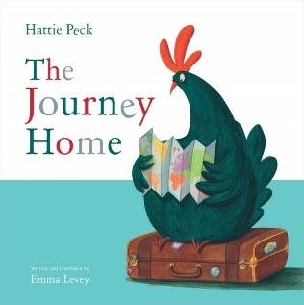 |  | 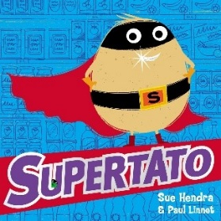
 | How can I use tools to make changes to materials? Can I show increasing control when using a variety of tools and objects? Can I form recognisable letters by myself? Am I usually dry and clean during the day | What is another way of travelling across the equipment? What different ways can I move? Which hand do I choose to write with? Can I hold a pencil effectively? How do I keep myself safe? | Can I move in a range of ways with confidence? How do I jump off an object safely? Do I show an awareness of space and safety when moving? Can I move and store equipment safely? | How can I negotiate the space around me when playing with my friends? Can I confidently get dressed and undressed for PE | Can I confidently go over, under or through apparatus? Do I talk about changes that happen in my body when I am feeling tired, unwell, anxious, angry or sad? Can I jump off an object and land safely? | Can I talk about healthy/unhealthy foods? Am I able to talk about why it is important to exercise, eat, sleep, drink water and keep clean? Do I talk about different food textures and tastes when cooking and notice changes when they are mixed or cooked/cooled?
Special Events |  | Bonfire Night  Diwali  Christmas | Chinese New Year  Pancake Day | Easter |  | Sports Day

