End of EYFS |  | Safely use and explore a variety of materials, tools and techniques, experimenting with colour, design, texture, form and function.  Share their creations, explaining the process they have used.  Make use of props and materials when role playing characters in narrative and stories.  Invent, adapt and recount narratives and stories with peers and their teacher.  Sing a range of well-known nursery rhymes and songs.  Perform songs, rhymes, poems and stories with others, and - when appropriate – try to move in time with music.
Caterpillars
 | All about me |  | Colours Everywhere | On the go | On the farm | Yummy foods | Seaside
 | 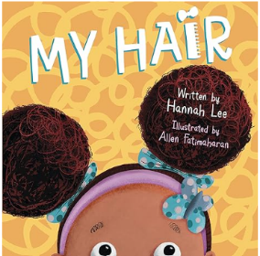 |  | 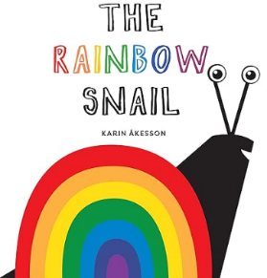 | 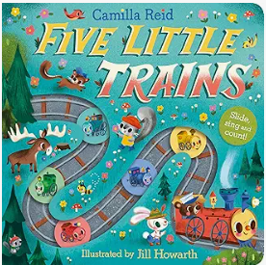 | 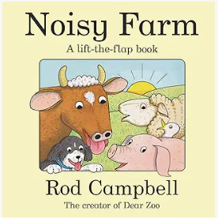 | 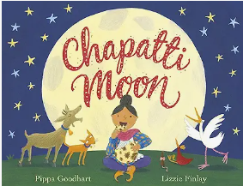 | 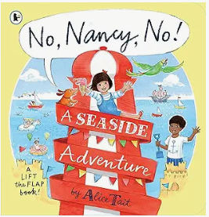
 | Can I create sounds by exploring different instruments?  Which sounds do I like the best?  Can I pretend to be someone else in my game?  Do I join in with dancing? |  | What colour do I need for the different parts of my picture?  Can I play an instrument quickly/slowly? | Can I join in with repeated parts and actions in familiar stories and songs?  Can I create sounds to fit with different parts of a story?  Can I make a loud or quiet sound? | Can I name familiar colours?  Do I have a favourite colour?  What can I hear?  Can I recognise and name some familiar everyday sounds? | Can I build my own model using a variety of construction resources?  Can I change my model or make it bigger?  What is my model?  What shape do I need? | What does this material/object feel like, hard, soft etc?  Which songs and rhymes make me happy?
 | Can I draw a picture of myself adding more detail?  What would happen if I mixed two colours together?  What other things might I need to improve my picture? |  | Can I create structures using different materials to compare houses for the pigs?  Why did I choose to use that particular material?  How can I make it stronger?  Do I re-enact my own experiences?  Can I create props I need for my imaginary play? | Can I move in different ways?  Can I join in with new ways of moving and dancing?  What is a pattern?  Do I copy things I have seen others do or events from stories? | Which tool will I need for this job?  Can I use scissors and tools safely?  What resources do I need for my game? | Can I recognise a variety of familiar sounds and name them?  What game are my friends playing? Can I join in with them independently? | What sounds can I hear on a windy day?  What sounds or actions might show that you are feeling cross, happy or sad?  Can I change sounds?  Can I sing familiar songs?
Butterflies
 | All about me |  | Celebrations of the world | Pirates! | New Life | Traditional tales | People who help us
 | 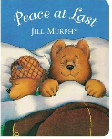 |  | 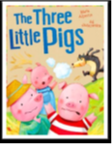 | 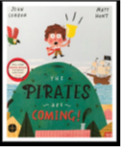 | 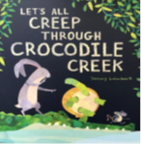 | 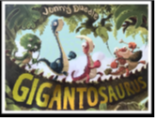 | 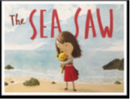
 | Can I draw a picture of myself adding more detail?  What would happen if I mixed two colours together?  What other things might I need to improve my picture? |  | Can I create structures using different materials to compare houses for the pigs?  Why did I choose to use that particular material?  How can I make it stronger?  Do I re-enact my own experiences?  Can I create props I need for my imaginary play? | Can I move in different ways?  Can I join in with new ways of moving and dancing?  What is a pattern?  Do I copy things I have seen others do or events from stories? | Which tool will I need for this job?  Can I use scissors and tools safely?  What resources do I need for my game? | Can I recognise a variety of familiar sounds and name them?  What game are my friends playing? Can I join in with them independently? | What sounds can I hear on a windy day?  What sounds or actions might show that you are feeling cross, happy or sad?  Can I change sounds?  Can I sing familiar songs?
Reception
 | All about me! |  | Mini-beasts | Transport | The World | Animals | Superheroes
 | 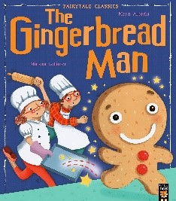 |  | 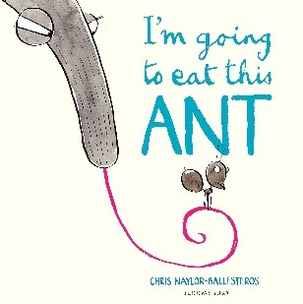 | 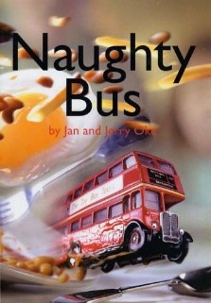 | 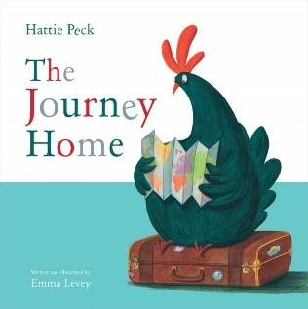 | 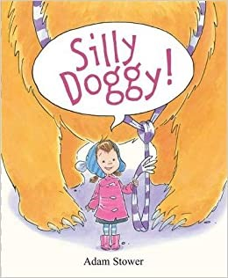 | 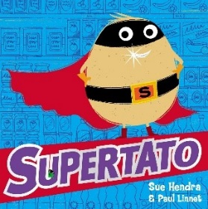
 | Can I give detailed descriptions to my pictures?  Why have I chosen to use that colour?  Which character am I?  What might happen next?  How will I solve that problem?  Do I experiment with different techniques? |  | Can I give commentary to my imaginative games?  Can I build what I need using the resources to hand to extend my imaginary play?  Do I pretend one thing represents another? | Can I sing a variety of nursery rhymes and songs?  What is my favourite song?  Can I make up my own song?  Can I talk about different types of music? | What does this music sound like?  Which song makes you feel happy?  Do any songs make you feel sad? | What have you made?  Can you tell me about your creation and why you have used that material?  What tools did you use?  Is there anything I could do to make it better? | Can I move along to the beat of a song?

