 | Autumn Term |  |  | Spring Term |  | Summer Term
End of EYFS | Say a sound for each letter in the alphabet and at least 10 diagraphs.  Read words consistent with their phonic knowledge by sound-blending.  Read aloud simple sentences and books that are consistent with their phonic knowledge, including some common exception words.  Write recognisable letters, most of which are correctly formed.  Spell words by identifying sounds in them and representing the sounds with a letter or letters.  Write simple sentences that can be read by others.
 | All about me |  | Colours Everywhere | On the go | On the farm | Yummy foods | Seaside
Caterpillars | 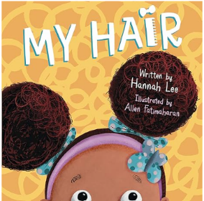 |  | 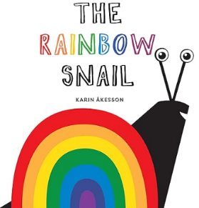 | 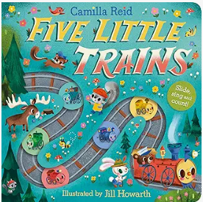 | 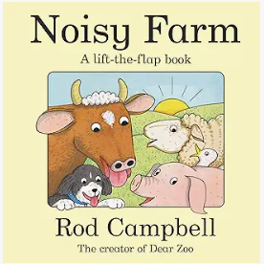 | 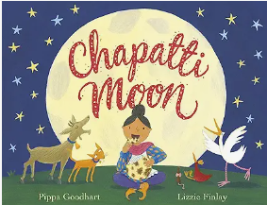 | 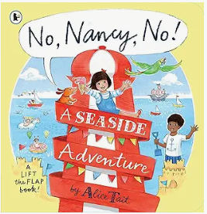
 | What is your favourite rhyme?  Do I join in with singing familiar rhymes?  What noise does an owl make?  Do I join in with sensory mark making activities such as painting, sand play, gloop and playdough?  Do I show an interest in looking at books and listening to stories? |  | Can you fill in the missing word, brown bear, brown bear, what do you. ___?  Do I show an interest in making marks?  Can I create models in the playdough and talk about what I have made?  Do I enjoy looking at books, know how to turn the pages myself and lift up flaps? | Can I join in with repeated words, actions or phrases from this story?  Can I act out some parts of familiar stories in my play?  What noise does the snowstorm make when they walk through it?  Do I explore mark making on different textures?  Can I explore different sounds a range of instruments make? | Can I recognise familiar signs and logos, such as the shops I go to or my favourite programmes/games icons?  Can I talk about what I have drawn?  What is your favourite story?  What did you like about this story?  Can you point to the picture of the baby?  Which way up do you hold a book? | Do I enjoy and join in with rhythmic and musical activities?  How do you play this instrument?  What noises might you hear on a farm?  Is a train loud or quiet?  Which animals did you see in this book?  What was your favourite thing the girl on the train saw? | Can I clap along to the beat of a song?  What sounds can you hear outside?  What sounds might you hear in a jungle?  Can I help to make up my own story with adult support?  Who is on the front page of this book?  Can you point at the words in this book?
Butterflies | 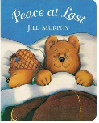 |  | 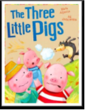 | 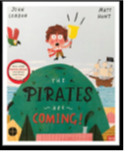 | 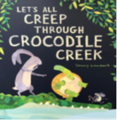 | 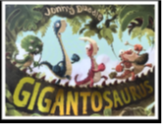 | 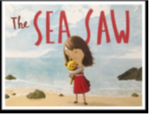
Reception | 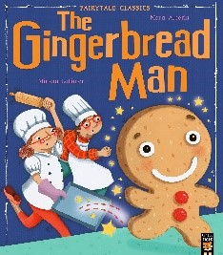 |  | 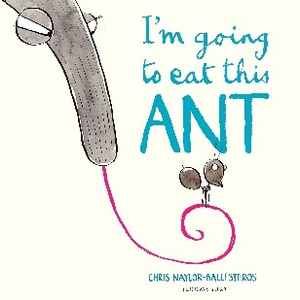 | 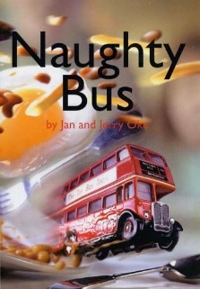 | 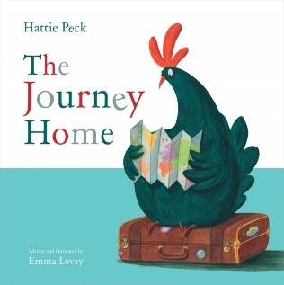 | 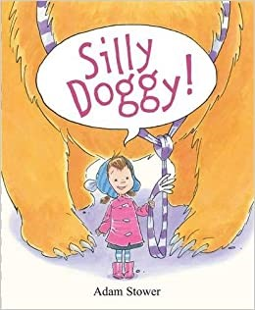 | 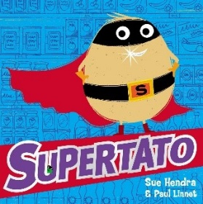
Special Events |  | Bonfire Night  Diwali  Christmas |  | Chinese New Year  Pancake Day | Easter

